FOR IMMEDIATE RELEASE
March 24, 2015 Media Contacts
City of Mason Kaity Dunn 513-793-1234
Kaity@rasormarketing.com
Intelligrated
Tracy Niehaus 513-881-5239
Tracy.Niehaus@intelligrated.com

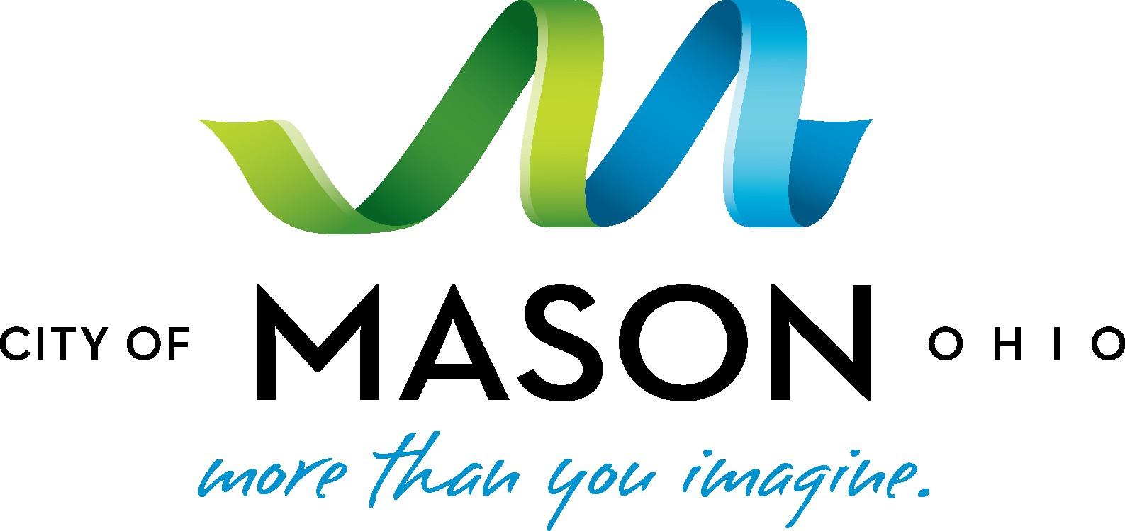

INTELLIGRATED GLOBAL ENGINEERING HEADQUARTERS GROWS AGAIN IN MASON

The City of Mason and the State of Ohio celebrate more than 80,000 square foot expansion adding more than 200 new engineering jobs

Mason, OH – (March 24, 2015) - Intelligrated®, a leading North American-based automated material handling solutions provider, today announced plans to expand its headquarters in Mason, OH, by 83,000 square feet plus structured parking in order to accommodate approximately 238 additional jobs, primarily in the engineering field. This is the company’s second headquarters expansion in Mason in two years, which will bring it to a total of 389,000 square feet. Intelligrated is one of the top five employers within the City of Mason and one of the top 20 private companies in Cincinnati as ranked by the Cincinnati Business Courier.

“We have great momentum right now and are moving quickly to leverage our market position for rapid growth. The City of Mason has been an outstanding partner and JobsOhio has consistently provided us with the resources and the right operating environment to remain the leader in automated material handling solutions. We are well-positioned in Mason and Ohio to attract the millennial talent we’ll need to fill the 238 additional positions we are adding,” said Chris Cole, CEO of Intelligrated.

With an investment of approximately $10.2 million in real property improvements, the expansion will build on Intelligrated’s current space with a three-story, Class A office building that includes additional structured parking on the first floor. The new space will house corporate engineering, research and development operations.

“This expansion is a direct testament to the vision of Chris Cole, the CEO of Intelligrated, and Jim McCarthy, the President and COO. As a City Council that is business-minded with entrepreneurs and private sector leaders, we have been a partner and facilitator throughout their history here in Mason. We understand and appreciate what it takes to achieve such phenomenal growth in such a short period of time and have worked hard to support their industry leadership,” said City of Mason Mayor, David F. Nichols. “We have been very intentional about fostering technology and bioscience growth in the I-71 corridor. It’s great to see that concept become reality.”

This is the third expansion announcement for Intelligrated since its establishment in 2001 and the fourth economic development investment announcement by Mason in Q1. Assurex Health, Mitsubishi and P&G have all announced investment in Mason this year.

A large facet of the City of Mason’s economic development strategy is to have well-established programs and partnerships with local universities to secure the attraction and retention of top talent. With the goal of providing the resources and support needed to help corporate partners, like Intelligrated, develop into global leaders, the City of Mason targets the millennial workforce through support of cooperative education (co-op) programs. Co-op programs offer a structured method of combining academic education with practical work experience to earn college credit. The

City of Mason also hosts annual job fairs with BioOhio, and last year, hosted a conference with the Ohio Cooperative Education Association (OCEA) in partnership with the University of Cincinnati to open dialogue among academics and corporate partners about effective training and education.

“Intelligrated’s choice of Ohio for this expansion is welcome news for Mason and the more than 230 additional workers who will soon be on the job there," said JobsOhio Managing Director Glenn Richardson. "We are excited about our continued partnership with this industry leader as they move forward with their investment in Ohio.”

"Intelligrated's decision further validates that the City of Mason is a great location for manufacturing companies to succeed," said Johnna Reeder, President & CEO of REDI Cincinnati. "We are proud of this win for our region and the City of Mason.”
-###-

About Intelligrated
Intelligrated® (www.intelligrated.com) is a leading North American-based, single-point provider of automated material handling solutions with operations in the U.S., Canada, Mexico, Brazil and China. Headquartered in Mason, OH, Intelligrated designs, manufactures and installs complete material handling automation systems for the warehousing, distribution, consumer product manufacturing, postal and parcel markets.

Intelligrated designs, manufactures, integrates and installs complete material handling automation solutions including conveyor systems, sortation systems, palletizers, robotics, automated storage and retrieval systems, and order picking technologies – all managed by advanced machine controls and software. Solutions include industry-leading Intelligrated-manufactured Alvey and IntelliSort® brand equipment, and warehouse management (WMS), warehouse control (WCS) and labor management software.

About the City of Mason, Ohio
Mason, Ohio, is an established hub for bioscience innovation and includes a business portfolio of advanced manufacturing, healthcare and technology companies. As the largest city in Warren County and part of the Greater Cincinnati region in southwest Ohio, Mason’s economic development mission is focused on attracting and supporting the growth of top companies and creating jobs in these key sectors, while leveraging partnerships to also attract foreign direct investment. Ranked the seventh best place to live by CNN/Money Magazine in 2013, Mason is nationally-recognized for its low cost of living, award-winning schools and its intentional culture of wellness.

