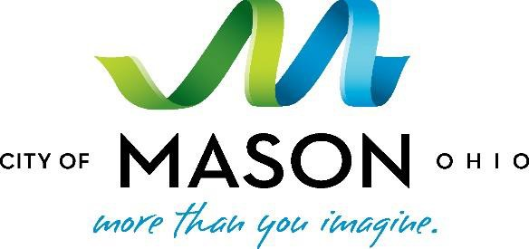

Media Contact:
Victoria Sabato, Rasor Marketing Communications
513-793-1234 (office) or 513-379-5855 (cell); victoria@rasormarketing.com

The City of Mason celebrates Innovation Night as part of
Mason Innovation Week, Presented by Festo, October 27
Live flying bionic technology demonstrations symbolic of City’s commitment to public-private partnerships as both pathway to strong economy and collaborative community education

(Mason, OH – October 26, 2015) Beginning Monday, October 26 the City of Mason celebrates Mason Innovation Week, an event presented by global automation technology leader Festo as its gift to the City for its Bicentennial celebration. Throughout the week, Festo’s Bionic Learning Network representatives will demonstrate their bio-inspired robotic animals, the SmartBird and BionicOpter to area elementary, high school and college students and the Mason corporate community.
The Week’s events demonstrate how unique public-private partnerships can advance community education and promote science, technology, engineering and mathematics (STEM) programming. As a partner, Festo brings worldwide leadership in automation technology and industrial training, significantly enhancing the City’s growing bioscience and technology sector.
“Mason Innovation Week is a concept developed in close partnership with Festo. In all of our economic development efforts, we recognize a big part of our success is our ability to attract and retain business partners who are aligned with making education a community priority, particularly as it relates to STEM programming,” said City of Mason Mayor David F. Nichols. “Innovation Week is an opportunity to showcase how our partnership with Festo, our local school districts and higher education partners has brought benefits beyond economic development, to directly support the community, education and talent development.”
Yannick Schilly, VP Operations and COO of Festo Corp, mirrored the mayor’s statement, “Our partnership with the City enables us to not only expand and grow within our own company, but allows us and our Bionic Learning Network to reach out to the community to demonstrate how principles from nature provide inspiration for technical applications and future technology. And most importantly, these bionic projects help inspire and enthuse young people to take an interest in technology and STEM fields.”
Festo’s robotic animals are engineering marvels that demonstrate how biomimicry inspires advanced automation technology. Inspired by the herring gull, Festo’s SmartBird with a wing-span of two meters and weighing approximately one pound can start, fly and land autonomously. Weighing about six ounces, Festo’s BionicOpter is modeled after the dragonfly. This ultra-lightweight flying robotic animal can master the flight capabilities of a helicopter, airplane and glider combined.
For additional information about Mason Innovation Week, Festo’s robotic animals and Festo’s Bionic Learning Network visit www.MasonInnovates.com.

###

About the City of Mason, Ohio
Mason, Ohio is an established hub for bioscience innovation and includes a business portfolio of advanced manufacturing, healthcare and technology companies. As the largest city in Warren County and part of the Greater Cincinnati region in southwest Ohio, Mason’s economic development mission is focused on attracting and supporting the growth of top companies and creating jobs in these sectors, while leveraging partnerships to also attract foreign direct investment. Ranked the seventh best place to live by CNN/Money Magazine in 2013 and 17th in 2015, Mason is nationally recognized for its low cost of living, award-winning schools and its intentional culture of wellness.

About Festo
Festo is a leading manufacturer of pneumatic and electromechanical systems, components, and controls for process and industrial automation. For more than 40 years, Festo Corporation has continuously elevated the state of manufacturing with innovations and optimized motion control solutions that deliver higher performing, more profitable automated manufacturing and processing equipment.
Connect with Festo: Facebook, LinkedIn, Twitter and YouTube

